第二章 矩阵

题：

题1：
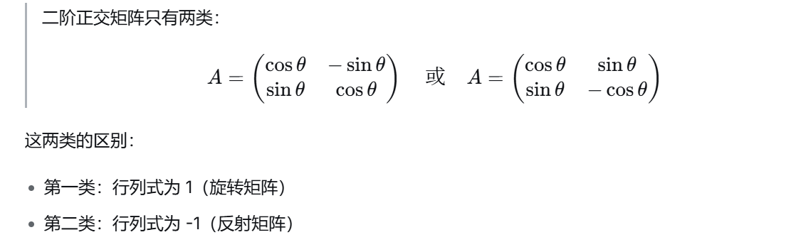
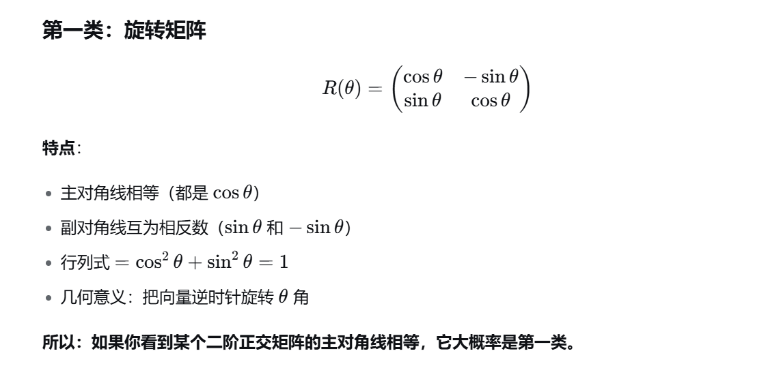
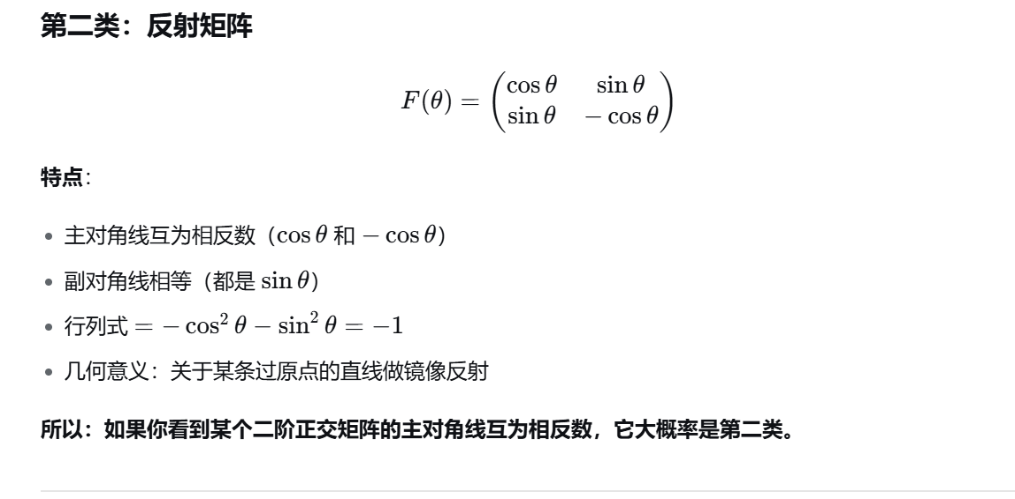

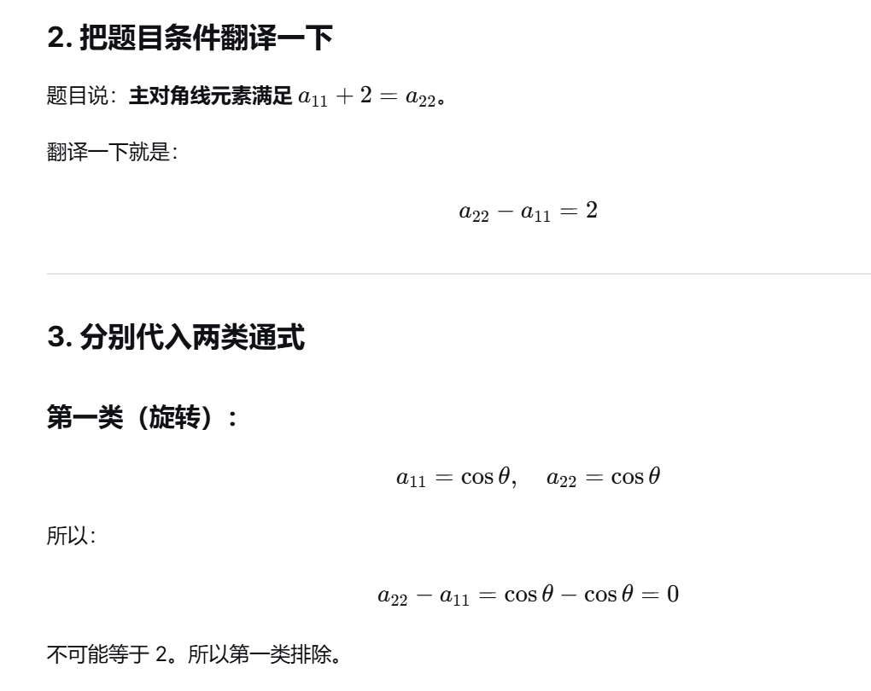
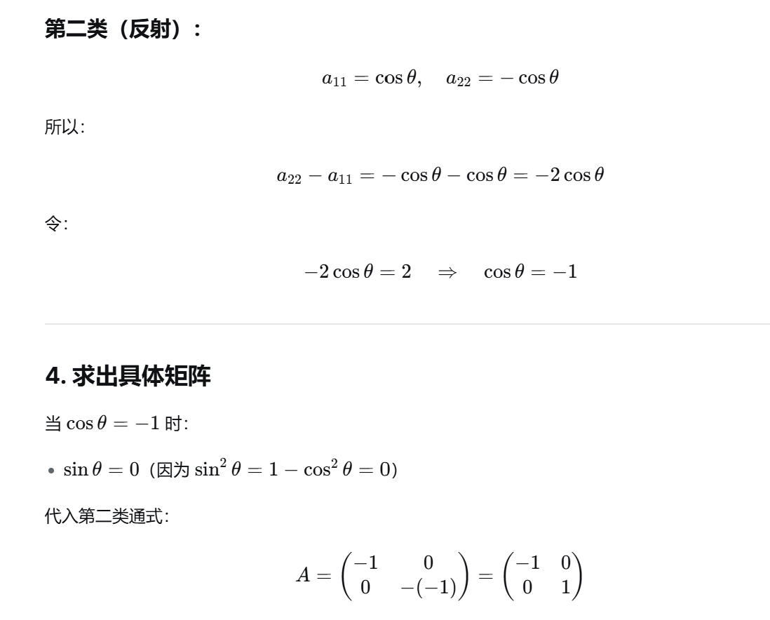
https://chatgpt.com/g/g-p-6a1d6c6f0a408191a175c887909fceb5-xian-dai-he-gai-lu-lun-ocr/c/6a709c29-6aec-83ee-9011-bb2fa47b13f8

题2：
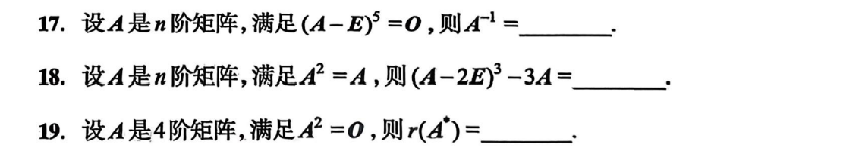
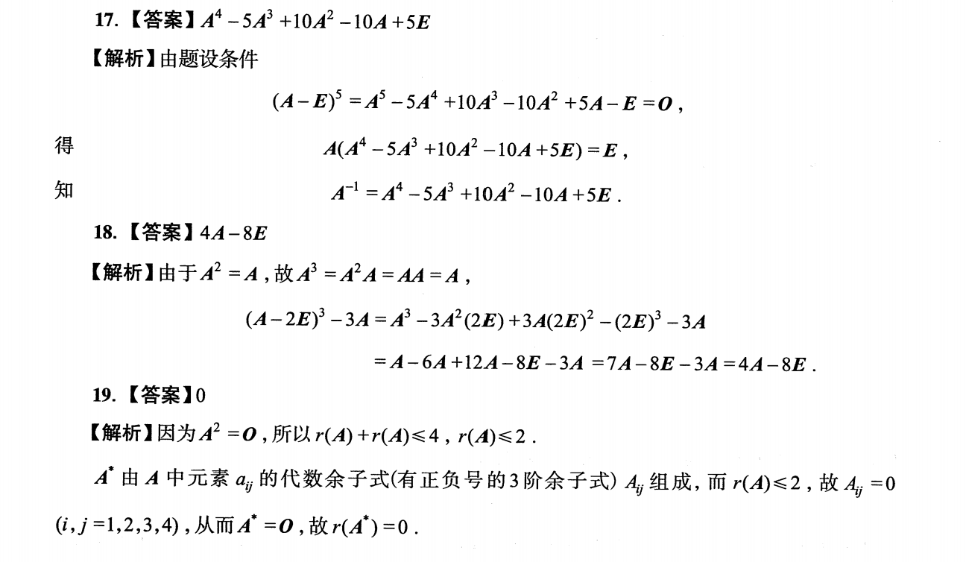

题3：
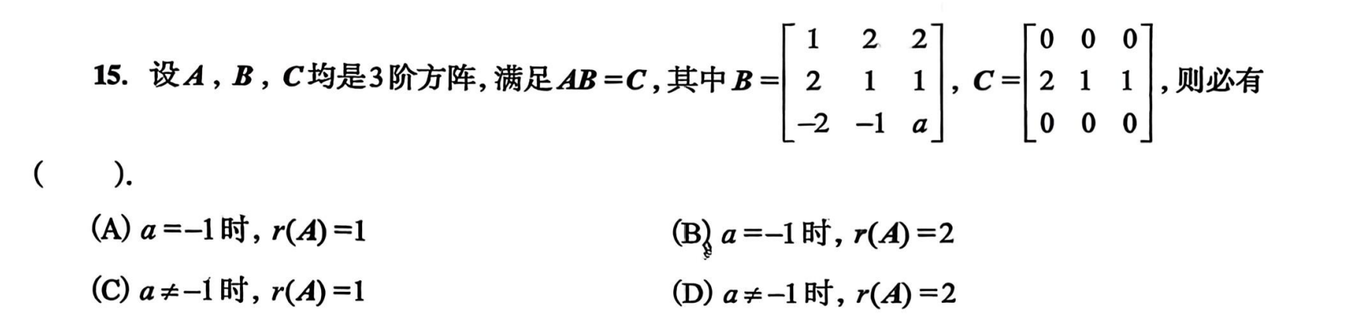
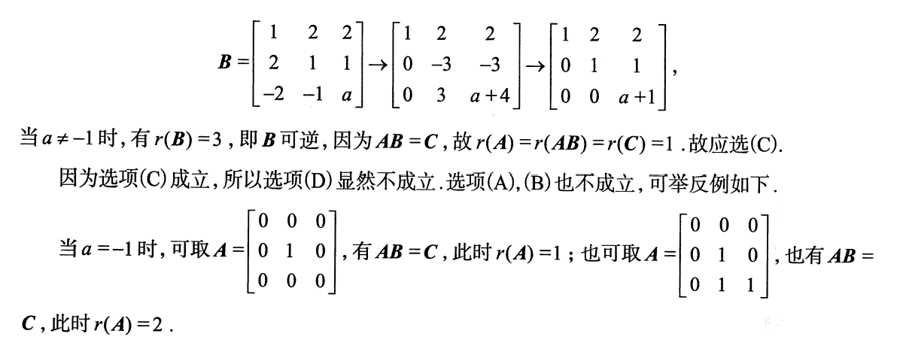
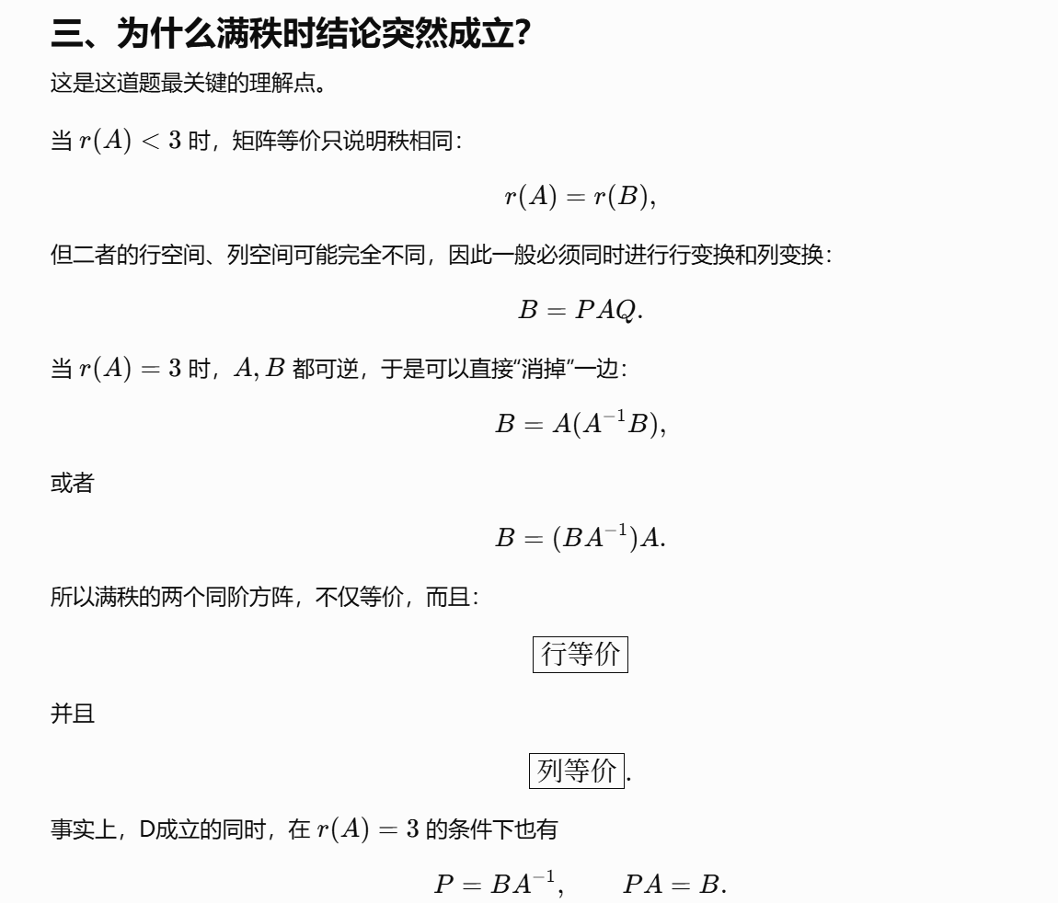
https://chatgpt.com/g/g-p-6a1d6c6f0a408191a175c887909fceb5-xian-dai-he-gai-lu-lun-ocr/c/6a71dc3f-41f4-83ee-949f-fffb56fcf66b

题4：
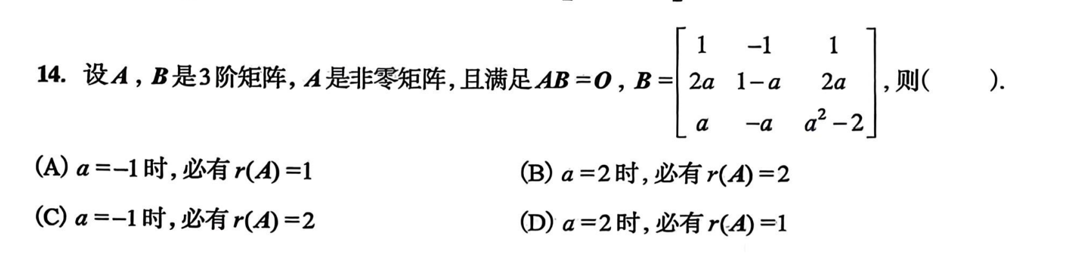
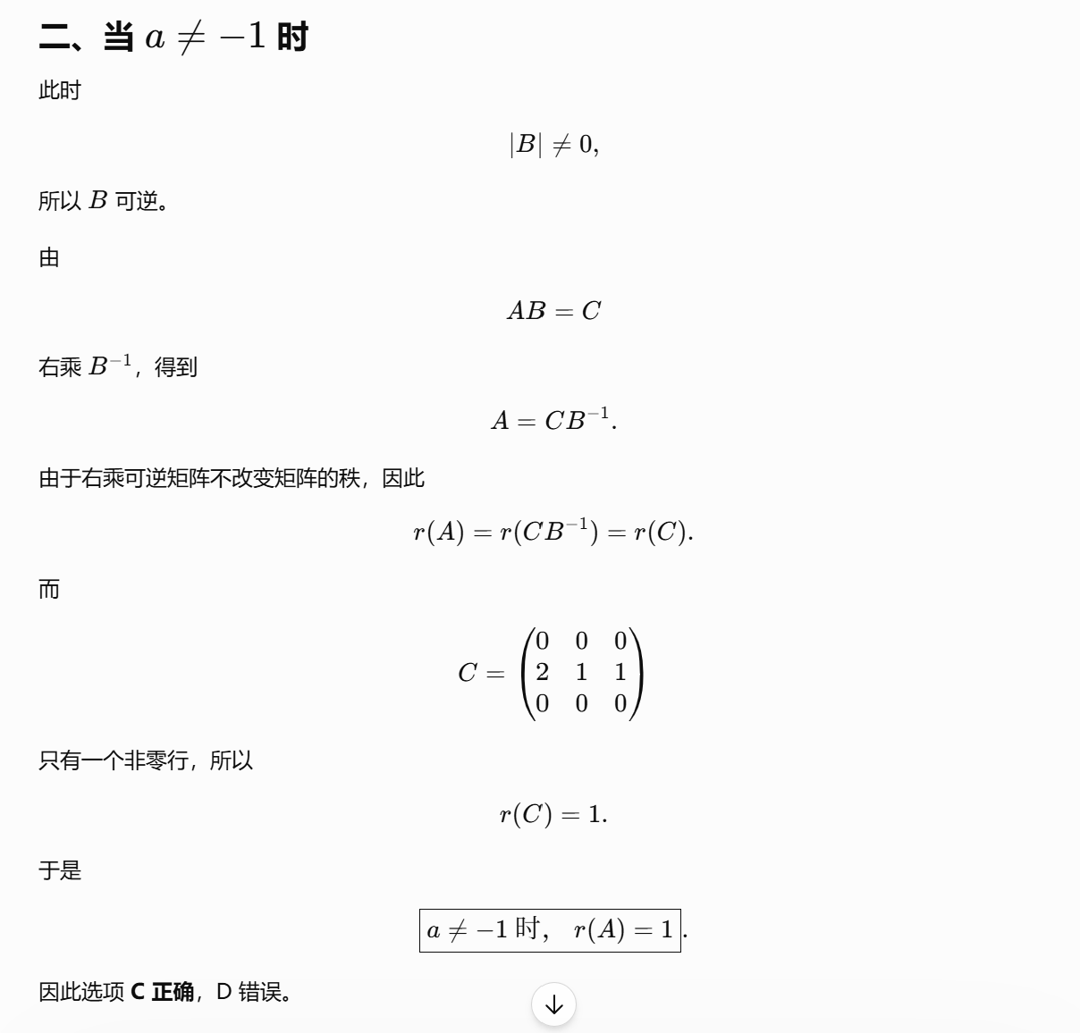
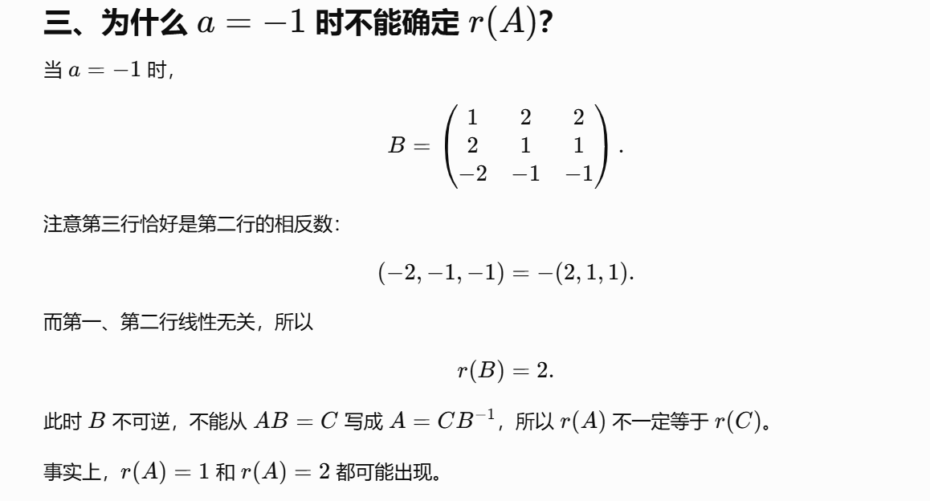
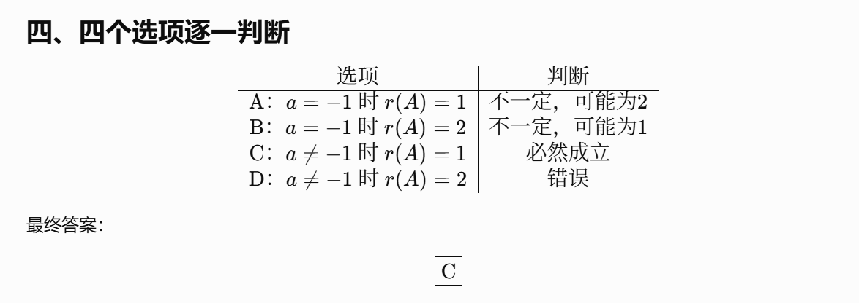
https://chatgpt.com/g/g-p-6a1d6c6f0a408191a175c887909fceb5-xian-dai-he-gai-lu-lun-ocr/c/6a71dce1-9edc-83e8-9388-e22e32cd3a6e
|（注：部分内容可能由 AI 生成）

